PCI Drivers

Q) Difference between plug and play and hot plug and play?
Ans:
Plug and play devices are those which can be inserted to the system anytime but not when system is up and running, and will be recognized by the system on startup.

Hot plug and play devices can be inserted and removed at anytime, even when system is up and running.

Plug and Play (PnP) is a technology that allows the operating system to detect and configure internal and external peripherals as well as most adapters. It has the ability to find and configure hardware components without having to reset DIP switches and jumpers.
Hotpluggable means the ability to be attached and removed from a running system without causing problems. USB is hot pluggable. Firewire is hot pluggable. PS/2 is (typically) not. PCI is (typically) not.

Q) Advantages of PCI over ISA?
Ans:
The Peripheral Component Interconnect, also known as PCI, has been licensed by Intel in the 1990s. The bus is used as a communication lane to transmit signals and data from your computer system to peripheral devices attached to the computer system. Compared to the earlier VL-bus and ISA, it has a higher performance capacity and avoids any risk of interference with your CPU.

The processor is connected to the other components like the hard drives, the main memory and the PCI slots by the use of a front-side bus. The speed of the front side bus can reach up to 400 Mhz with a system operating at the speed of 800 Mhz.

Different Bus Types
- PCI 32 bits have a bus speed of 33 MHz and operate at 132 MBps
- PCI 64 bits have a bus speed of 33 MHz and operate at 264 MBps
- PCI 64 bits have a bus speed of 66 MHz and operate at 512 MBps
- PCI 64 bits have a bus speed of 66 MHz and operate at 1 GBps.

Advantages of PCI
The PCI technology offers a number of advantages compared to the VL-Bus or ISA.
- 1. You can connect a maximum of five components to the PCI and you can also replace each of them by fixed devices on the motherboard.
- 2. You an have multiple PCI buses on the same computer
- 3. The PCI bus will enhance the speed of the transfers from 33MHz to 133 MHz with a transfer rate of 1 gigabyte per second.
- 4. The PCI can handle devices using a maximum of 5 volts and the pins used can transfer more that one signal through one pin.

Q) PCI features
Ans:
Buses (upto 256) -> Devices (upto 32)/bus -> Functions (upto 8)/device.

Organized as PCI Core (drivers of PCI controller)
PCI Drivers (device drivers)

Q) Who assigns Address of PCI devices?
Ans:
During bootup, the BIOS assigns the addresses of PCI devices.

On all IBM PC-compatible machines, BARs are assigned by the BIOS. Linux simply scans through the buses and records the BAR values.
Some MIPS boards adopt similar approaches, where BARs are assigned by firmware. However, the quality of BAR assignment by firmware vary quite a bit. Some firmware simply assigns BARs to on-board PCI devices and ignore all add-on PCI cards. In that case, Linux cannot solely rely on the firmware's assignment.
There is another issue of depending on the firmware assignment. You need to stick with the address range setup by the firmware. In other words, if the firmware assigns PCI memory space from 0x10000000 to 0x14000000, you cannot easily move it to a different address space somewhere else in Linux.
In some cases, addresses are assigned by PCI core (Bootloader or kernel). It must be assigned by the time driver comes up.

Q) PCI Configuration Space
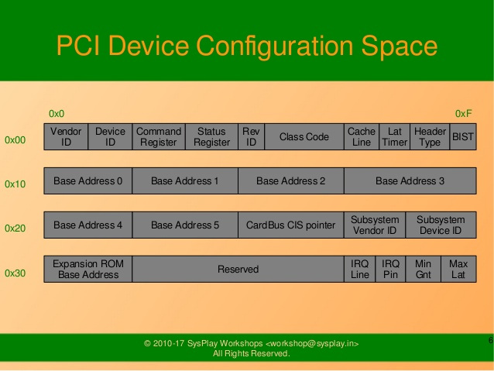

Q) APIs to read/write PCI configuration space values?
Ans:
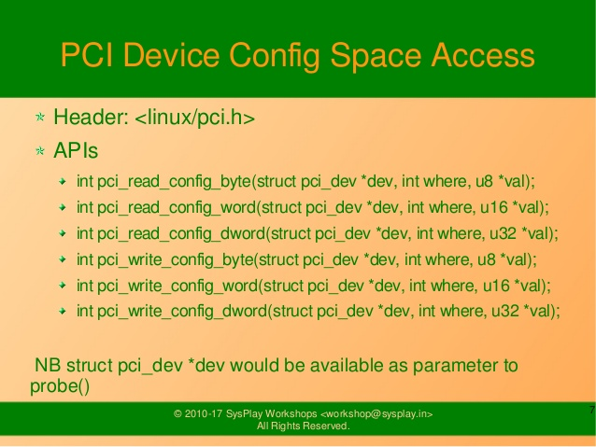

Q) APIs to access PCI devices?
Ans:
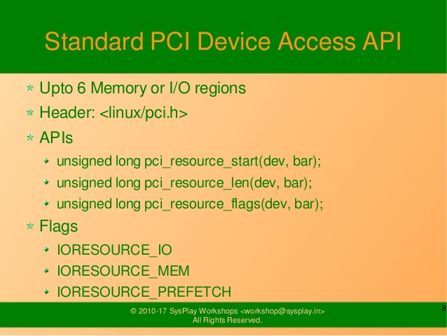
Q) APIs to write PCI Drivers?
Ans:
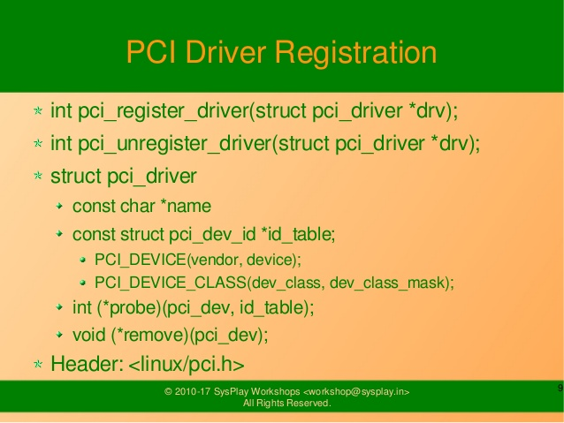

Q) Functions called inside a PCI probe function?
Ans:
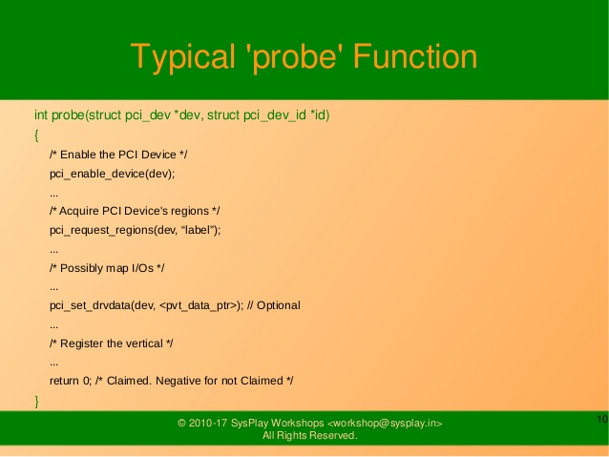

Q)
PCI Notes

-Peripheral Component Interconnect.
-Plug and Play
-PCI interface contains registers.
-allows PC to configure the card.

-PCI devices are controlled by a PCI Controller.

PCI Bus
-PCI functions with a 32-bit or 64-bit data bus and a full 32-bit address bus.
AD0-AD31-multiplexed.
AD32-AD64 – data transfer only.
-32bit card – 1-62 connections
-64-bit card – 1-94 connections

PCI Clock
PCI – 33 Mhz
PCI2.0 – 66Mhz

PCI Bus signals
PCICLK
FRAME(bar) -
AD bus
C/BE(bar) -

Configuration space
256-byte memory – for the PC to interrogate the PCI interface.
allows system to automatically configure itself for the PCI plug-board.

First 64-byte – info about the interface
first 32-bits – unit ID code and vendor ID code.
Next 32-bits – command and status info
next 8 bits – revision id
next 24 bits – class code – type of device (graphics, ethernet etc)

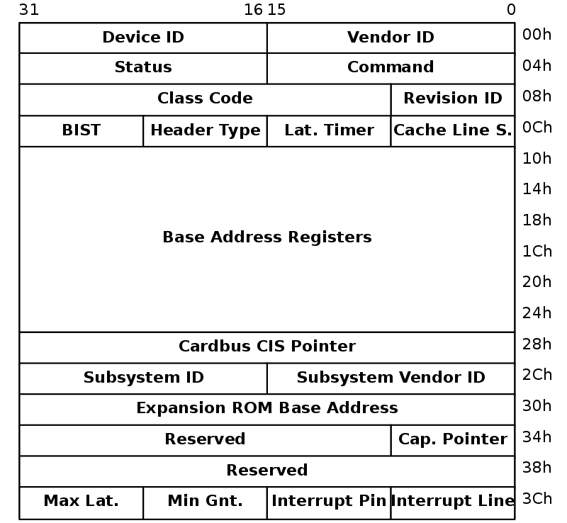

BAR – Base Address register – stores the starting addresses of the resources of the PCI device (registers, RAM, EEPROM etc)
6 X 4bytes – 0x10, 0x14, 0x18, 0x1C, 0x20, 0x24

Bios writes to the BAR during booting.

The resource have to be mapped to the address space of the host (memory or I/O). BAR is used for that.

The firmware identifies the size of each addressable region by writing all 1's to the base address register and then reading back the value. The device will return 0's in all don't-care address bits, effectively specifying the size of the address space.

Command and status registers
The PCI configuration space Command register controls various properties of a PCI device including:
- Enabling I/O space
- Enabling Memory space
- Enabling Bus Mastering
The PCI Status register also contains information about the outcome of recent PCI transactions. The Director SBC clears this register at the end of the configuration phase.

MOV AH, 0B1H – access PCI BIOS
INT 1AH – command in BIOS to execute PCI functions

PCI Express (PCIe)
-transfers data in serial at 2.5 Ghz to legacy PCI applications.
-250 Mbps to 8 Gbps for PCIe interface (generation 1)
-std PCI 133Mbps

-Each serial connection on PCIe bus is called lane.

Writing PCI Drivers

Step1 - register()
PCI drivers “discover” PCI devices in a system via pci_register_driver().

pci_register_driver() leaves most of the probing for devices to the PCI layer and supports online insertion/removal of devices

pci_register_driver() call requires passing in a table of function pointers and thus dictates the high level structure of a driver.

Step2 - probe()
Once the driver knows about a PCI device and takes ownership, the driver generally needs to perform the following initialization:
- Enable the device
- Request MMIO/IOP resources
- Set the DMA mask size (for both coherent and streaming DMA)
- Allocate and initialize shared control data (pci_allocate_coherent())
- Access device configuration space (if needed)
- Register IRQ handler
- Initialize non-PCI (i.e. LAN/SCSI/etc parts of the chip)
- Enable DMA/processing engines
Step3 – remove()
When done using the device, and perhaps the module needs to be unloaded, the driver needs to take the follow steps:
- Disable the device from generating IRQs
- Release the IRQ
- Stop all DMA activity
- Release DMA buffers (both streaming and coherent)
- Unregister from other subsystems (e.g. scsi or netdev)
- Release MMIO/IOP resources
- Disable the device

1. pci_register_driver()

PCI device drivers call pci_register_driver() during their initialization with a pointer to a structure describing the driver (struct pci_driver).

struct pci_driver {
struct list_head node;
const char *name;
const struct pci_device_id *id_table;
int (*probe)(struct pci_dev *dev, const struct pci_device_id *id);
void (*remove)(struct pci_dev *dev);
int (*suspend)(struct pci_dev *dev, pm_message_t state);
int (*resume)(struct pci_dev *dev);
void (*shutdown)(struct pci_dev *dev);
int (*sriov_configure)(struct pci_dev *dev, int num_vfs);
const struct pci_error_handlers *err_handler;
const struct attribute_group **groups;
struct device_driver driver;
struct pci_dynids dynids;
};
node
List of driver structures.
name
Driver name.
id_table
Pointer to table of device IDs the driver is interested in. Most drivers should export this table using MODULE_DEVICE_TABLE(pci,…).
probe
This probing function gets called (during execution of pci_register_driver() for already existing devices or later if a new device gets inserted) for all PCI devices which match the ID table and are not “owned” by the other drivers yet.This function gets passed a “struct pci_dev *” for each device whose entry in the ID table matches the device. The probe function returns zero when the driver chooses to take “ownership” of the device or an error code (negative number) otherwise. The probe function always gets called from process context, so it can sleep.
remove
The remove() function gets called whenever a device being handled by this driver is removed (either during deregistration of the driver or when it’s manually pulled out of a hot-pluggable slot). The remove function always gets called from process context, so it can sleep.

suspend
Put device into low power state.

resume
Wake device from low power state.

groups
Sysfs attribute groups.
driver
Driver model structure.

The ID table is an array of struct pci_device_id entries ending with an all-zero entry. Definitions with static const are generally preferred.

struct pci_device_id {
__u32 vendor, device;
__u32 subvendor, subdevice;
__u32 class, class_mask;
kernel_ulong_t driver_data;
};
driver_data
Data private to the driver. Most drivers don’t need to use driver_data field.

Most drivers only need PCI_DEVICE() or PCI_DEVICE_CLASS() to set up a pci_device_id table.
New PCI IDs may be added to a device driver pci_ids table at runtime as shown below:

echo "vendor device subvendor subdevice class class_mask driver_data" > \
/sys/bus/pci/drivers/{driver}/new_id
All fields are passed in as hexadecimal values (no leading 0x). The vendor and device fields are mandatory, the others are optional.

Once added, the driver probe routine will be invoked for any unclaimed PCI devices listed in its (newly updated) pci_ids list.

2. pci_unregister_driver()

When the driver exits, it just calls pci_unregister_driver() and the PCI layer automatically calls the remove hook for all devices handled by the driver.

3. searching for devices
A PCI device can be manually searched from the code using:
struct pci_dev *dev = NULL;
while (dev = pci_get_device(VENDOR_ID, DEVICE_ID, dev))
configure_device(dev);

Searching by class ID (iterate in a similar way):
pci_get_class(CLASS_ID, dev)

Searching by both vendor/device and subsystem vendor/device ID:
pci_get_subsys(VENDOR_ID,DEVICE_ID, SUBSYS_VENDOR_ID, SUBSYS_DEVICE_ID, dev)

You must eventually (possibly at module unload) decrement the reference count on these devices by calling pci_dev_put().

4. probe()

First step
Before touching any device registers, the driver needs to enable the PCI device by calling pci_enable_device().
This will:
- wake up the device if it was in suspended state,
- allocate I/O and memory regions of the device (if BIOS did not),
- allocate an IRQ (if BIOS did not).
pci_set_master() will enable DMA by setting the bus master bit in the PCI_COMMAND register. It also fixes the latency timer value if it’s set to something bogus by the BIOS. pci_clear_master() will disable DMA by clearing the bus master bit.

Second step

Memory (MMIO), and I/O port addresses should NOT be read directly from the PCI device config space. Use the values in the pci_dev structure as the PCI “bus address” might have been remapped to a “host physical” address by the arch/chip-set specific kernel support.

The device driver needs to call pci_request_region() to verify no other device is already using the same address resource. Conversely, drivers should call pci_release_region() AFTER calling pci_disable_device(). The idea is to prevent two devices colliding on the same address range.

long iobase = pci_resource_start (pdev, bar);
long iosize = pci_resource_len (pdev, bar);

Third step
While all drivers should explicitly indicate the DMA capability (e.g. 32 or 64 bit) of the PCI bus master, devices with more than 32-bit bus master capability for streaming data need the driver to “register” this capability by calling pci_set_dma_mask() with appropriate parameters. In general this allows more efficient DMA on systems where System RAM exists above 4G _physical_ address.

Drivers for all PCI-X and PCIe compliant devices must call pci_set_dma_mask() as they are 64-bit DMA devices.

Similarly, drivers must also “register” this capability if the device can directly address “consistent memory” in System RAM above 4G physical address by calling pci_set_consistent_dma_mask().

If the device can use the PCI MemoryWriteInvalidate transaction (writing entire cache lines), you can also call pci_set_mwi():
This enables the PCI_COMMAND bit for MemoryWriteInvalidate
This also ensures that the cache line size register is set correctly.

Fourth step
Once the DMA masks are set, the driver can allocate “consistent” (a.k.a. shared) memory.

Fifth step
Some drivers will need specific “capability” fields programmed or other “vendor specific” register initialized or reset. E.g. clearing pending interrupts.

Sixth step
While calling request_irq() is the last step described here, this is often just another intermediate step to initialize a device. This step can often be deferred until the device is opened for use.

All interrupt handlers for IRQ lines should be registered with IRQF_SHARED and use the devid to map IRQs to devices (remember that all PCI IRQ lines can be shared).

request_irq() will associate an interrupt handler and device handle with an interrupt number. Historically interrupt numbers represent IRQ lines which run from the PCI device to the Interrupt controller. With MSI and MSI-X (more below) the interrupt number is a CPU “vector”.

request_irq() also enables the interrupt. Make sure the device is quiesced and does not have any interrupts pending before registering the interrupt handler.

MSI and MSI-X are PCI capabilities. Both are “Message Signaled Interrupts” which deliver interrupts to the CPU via a DMA write to a Local APIC. The fundamental difference between MSI and MSI-X is how multiple “vectors” get allocated. MSI requires contiguous blocks of vectors while MSI-X can allocate several individual ones.

MSI capability can be enabled by calling pci_alloc_irq_vectors() with the PCI_IRQ_MSI and/or PCI_IRQ_MSIX flags before calling request_irq(). This causes the PCI support to program CPU vector data into the PCI device capability registers.

Flags that can be passed to pci_alloc_irq_vectors – PCI_IRQ_MSI | PCI_IRQ_MSIX | PCI_IRQ_LEGACY

Drivers that have different interrupt handlers for MSI/MSI-X and legacy INTx should chose the right one based on the msi_enabled and msix_enabled flags in the pci_dev structure after calling pci_alloc_irq_vectors.

There are (at least) two really good reasons for using MSI:
- MSI is an exclusive interrupt vector by definition. This means the interrupt handler doesn’t have to verify its device caused the interrupt.
- MSI avoids DMA/IRQ race conditions. DMA to host memory is guaranteed to be visible to the host CPU(s) when the MSI is delivered. This is important for both data coherency and avoiding stale control data. This guarantee allows the driver to omit MMIO reads to flush the DMA stream.

5. remove()

Step1
Stop IRQs on the device
If it’s not done, it opens the possibility of a “screaming interrupt” if (and only if) the IRQ is shared with another device.

When the shared IRQ handler is “unhooked”, the remaining devices using the same IRQ line will still need the IRQ enabled. Thus if the “unhooked” device asserts IRQ line, the system will respond assuming it was one of the remaining devices asserted the IRQ line. Since none of the other devices will handle the IRQ, the system will “hang” until it decides the IRQ isn’t going to get handled and masks the IRQ (100,000 iterations later). Once the shared IRQ is masked, the remaining devices will stop functioning properly.

MSI and MSI-X are defined to be exclusive interrupts and thus are not susceptible to the “screaming interrupt” problem.

Step2
Once the device is quiesced (no more IRQs), one can call free_irq(). This function will return control once any pending IRQs are handled, “unhook” the drivers IRQ handler from that IRQ, and finally release the IRQ if no one else is using it.

Step3
Stop all DMA Activity
It’s extremely important to stop all DMA operations BEFORE attempting to deallocate DMA control data. Failure to do so can result in memory corruption, hangs, and on some chip-sets a hard crash.

Stopping DMA after stopping the IRQs can avoid races where the IRQ handler might restart DMA engines.

Step4
Release DMA Buffers
Once DMA is stopped, clean up streaming DMA first. I.e. unmap data buffers and return buffers to “upstream” owners if there is one.

Then clean up “consistent” buffers which contain the control data.

Step5
Unregister from other subsystems
Most low level PCI device drivers support some other subsystem like USB, ALSA, SCSI, NetDev, Infiniband, etc. Make sure your driver isn’t losing resources from that other subsystem. If this happens, typically the symptom is an Oops (panic) when the subsystem attempts to call into a driver that has been unloaded.

Step 6
Disable device from responding to MMIO/IO Port Addresses

io_unmap() MMIO or IO Port resources and then call pci_disable_device().

Step7
Call pci_release_region() to mark the MMIO or IO Port range as available. Failure to do so usually results in the inability to reload the driver.

Accessing PCI Config space

You can use pci_(read|write)_config_(byte|word|dword) to access the config space of a device represented by struct pci_dev *. All these functions return 0 when successful or an error code (PCIBIOS_…) which can be translated to a text string by pcibios_strerror. Most drivers expect that accesses to valid PCI devices don’t fail.
If you don’t have a struct pci_dev available, you can call pci_bus_(read|write)_config_(byte|word|dword) to access a given device and function on that bus.
If you access fields in the standard portion of the config header, please use symbolic names of locations and bits declared in <linux/pci.h>.

Other functions

pci_resource_start() | Returns bus start address for a given PCI region
pci_resource_end() | Returns bus end address for a given PCI region

pci_set_drvdata() | Set private driver data pointer for a pci_dev
pci_get_drvdata() | Return private driver data pointer for a pci_dev

When displaying PCI device names to the user (for example when a driver wants to tell the user what card has it found), please use pci_name(pci_dev).

Always refer to the PCI devices by a pointer to the pci_dev structure. All PCI layer functions use this identification and it’s the only reasonable one.

Write posting
Converting a driver from using I/O Port space to using MMIO space often requires some additional changes. Specifically, “write posting” needs to be handled.

I/O Port space guarantees write transactions reach the PCI device before the CPU can continue.
Writes to MMIO space allow the CPU to continue before the transaction reaches the PCI device.

HW weenies call this “Write Posting” because the write completion is “posted” to the CPU before the transaction has reached its destination.

Thus, timing sensitive code should add readl() where the CPU is expected to wait before doing other work.

When resetting a PCI device. Use PCI Configuration space reads to flush the writel(). This will gracefully handle the PCI master abort on all platforms if the PCI device is expected to not respond to a readl(). Most x86 platforms will allow MMIO reads to master abort (a.k.a. “Soft Fail”) and return garbage (e.g. ~0). But many RISC platforms will crash (a.k.a.”Hard Fail”).

PCI Functions and prototype

1) int pci_register_device(struct pci_driver *pci_drv);

2) int pci_unregister_device(struct pci_driver *pci_drv);

3) int probe(struct pci_dev *dev, pci_device_id *id){...}

4) int remove(struct pci_dev *dev){...}

5) int pci_enable_device(struct pci_dev *dev);

6) int pci_request_regions(struct pci_dev *dev, const char *name);

7) int ioremap(pci_resource_start(struct pci_dev *dev, int BARnumber), pci_resource_length(struct pci_dev *dev,int BARnumber))

8) int pci_enable_msi(struct pci_dev *dev);

9) int pci_dev_msi_enabled(struct pci_dev *dev);

10) int pci_disable_msi(struct pci_dev *dev);

11) void pci_set_drvdata(struct pci_dev *dev, void *data);

12) void* pci_get_drvdata(struct pci_dev *dev);

13) const char *pci_name(const struct pci_dev *dev);

14) void pci_release_regions(struct pci_dev *dev)

Q) What is the use of MODULE_DEVICE_TABLE macro?
Ans:

This Macro is used by all USB and PCI drivers. This macro describes which devices each specific driver can support. At compilation time, the build process extracts this information out of the driver and builds a table. The table is called modules.pcimap and modules.usbmap for all PCI and USB devices, respectively, and exists in the directory /lib/modules/kernel_version/.
e.g.:-
static struct usb_device_id puzzle_id_table[]=
{
{ USB_DEVICE(VENDOR_ID,PRODUCT_ID) },
{0,},
};
MODULE_DEVICE_TABLE(usb,puzzle_id_table);
This will add following lines to modules.usbmap
# usb module match_flags idVendor idProduct bcdDevice_lo bcdDevice_hi bDeviceClass bDeviceSubClass bDeviceProtocol bInterfaceClass bInterfaceSubClass bInterfaceProtocol driver_info
lkm 0×0003 0×0951 0×1653 0×0000 0×0000 0×00 0×00 0×00 0×00 0×00 0×00 0×0
The macro MODULE_DEVICE_TABLE automatically creates two variables. For the example: MODULE_DEVICE_TABLE (usb, puzzle_id_table); the variables __module_usb_device_size and __module_usb_device_table are created and placed into the read-only data section and the initialized data section of the module, respectively. The variable __module_usb_device_size contains the value of the size of the struct usb_id structure, and __module_usb_device_table points to the puzzle_id_table structure. The puzzle_id_table variable is an array of usb_id structures with a terminating NULL structure at the end of the list.
When the depmod program is run, as part of the kernel installation process, it goes through every module looking for the symbol __module_usb_device_size to be present in the compiled module. If it finds it, it copies the data pointed to by the __module_usb_device_table symbol into a structure, extracts all of the information and writes it out to the modules.usbmap file, which is located in the module root directory.

